

**American International University- Bangladesh**

**CSC 3215: Web Technologies**

**CO2 and CO4 Evaluation**

**Finished Project Report**

**Spring/Summer/Fall 2020-2021**

**Project Title: Service Management System**

**Section: H**

|  |  |
| --- | --- |
| Student Name | Student Id |
| Johura, Fatematuj | **18-37846-2** |
| Hasan,Md.Mahmudul | **18-38677-3** |
| Ifti,Md.Iftiare Hossain | **18-39136-3** |
|  |  |

**Project Description:**

“Service Management System” Services is Bangladeshi leading chain of multi-brand Electronics and Electrical service workshops offering wide array of services. We focus on enhancing your uses experience by offering world-class Electronic Appliances maintenance services. Our sole mission is “To provide Electronic Appliances care services to keep the devices fit and healthy and customers happy and smiling”. With well-equipped Electronic Appliances service centres and fully trained mechanics, we provide quality services with excellent packages that are designed to offer you great savings. Our state-of-art workshops are conveniently located in many cities across the country. Now you can book your service online by doing Registration.

**Project Folder Structure:**

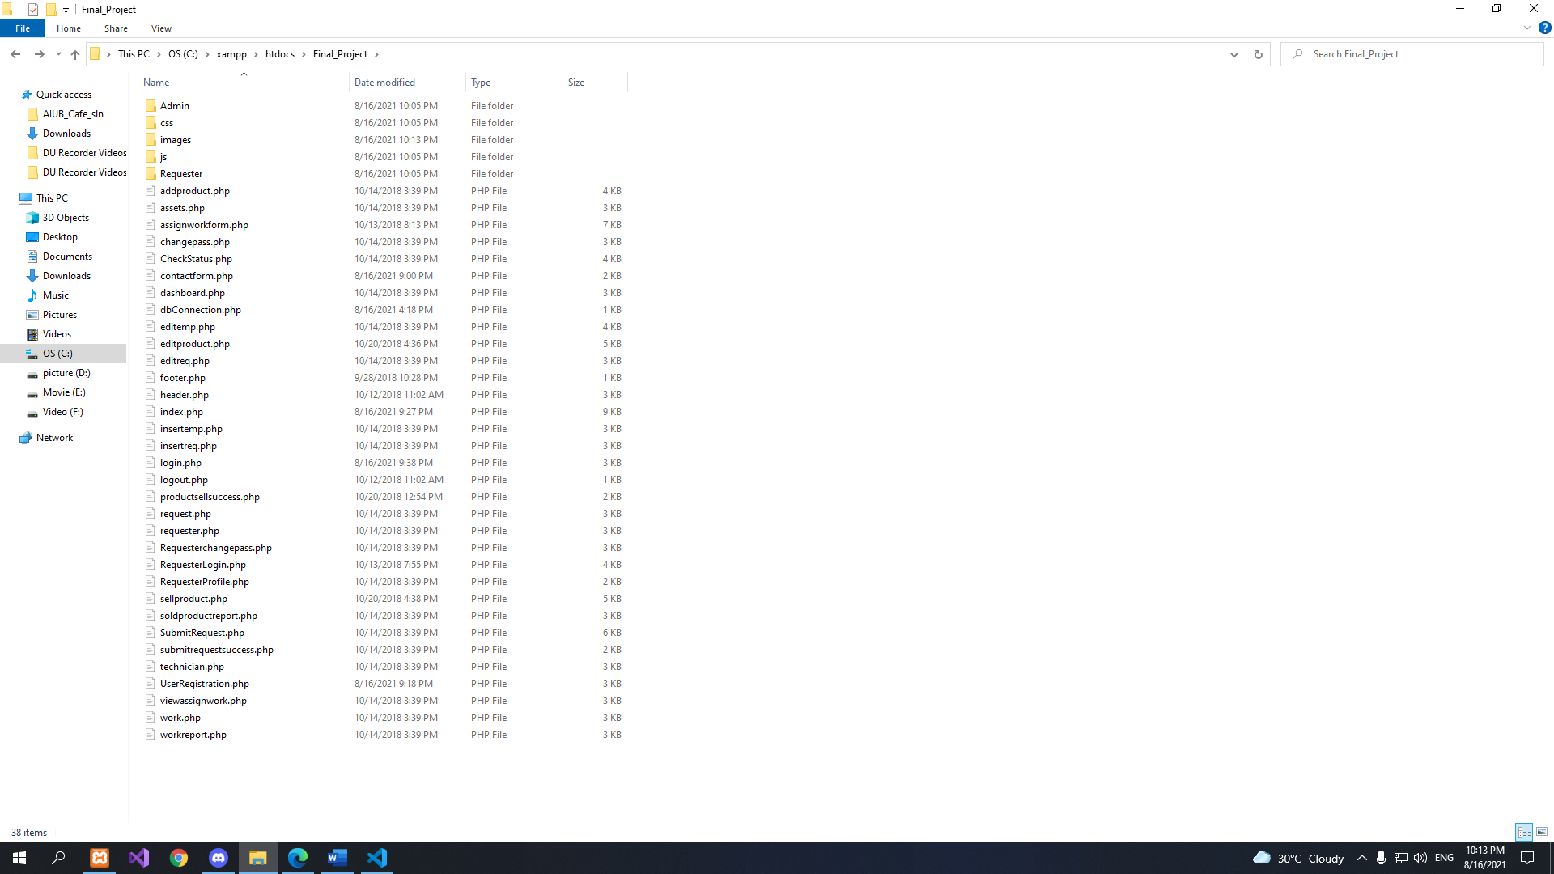

**Core Modules of the Project:**

*For example:*

***login.php***

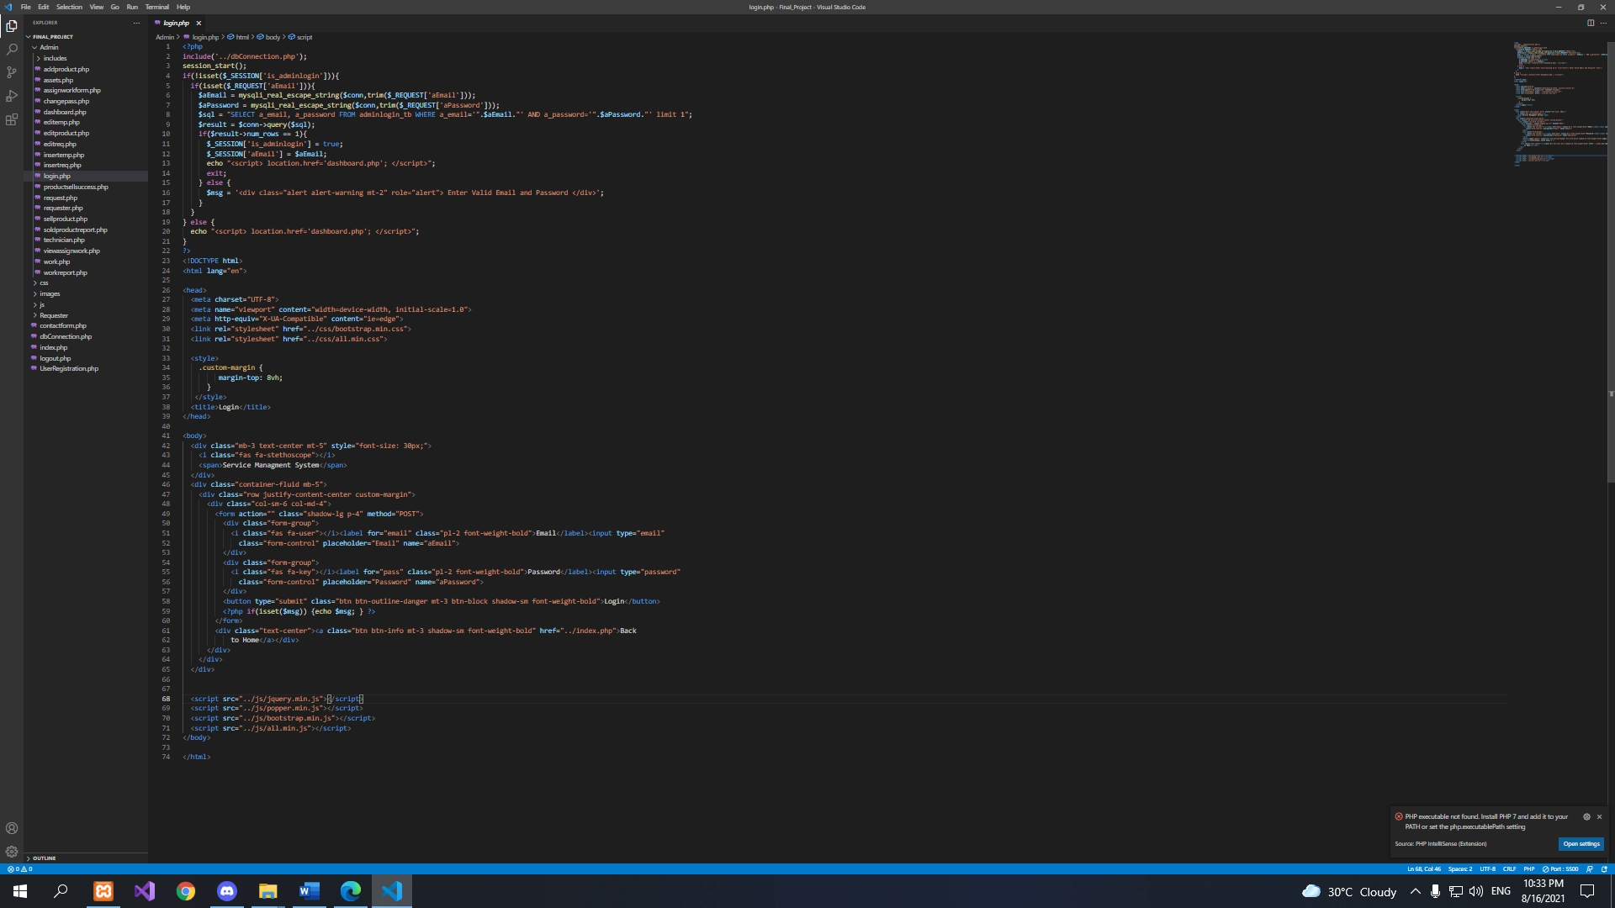

***shop.php***

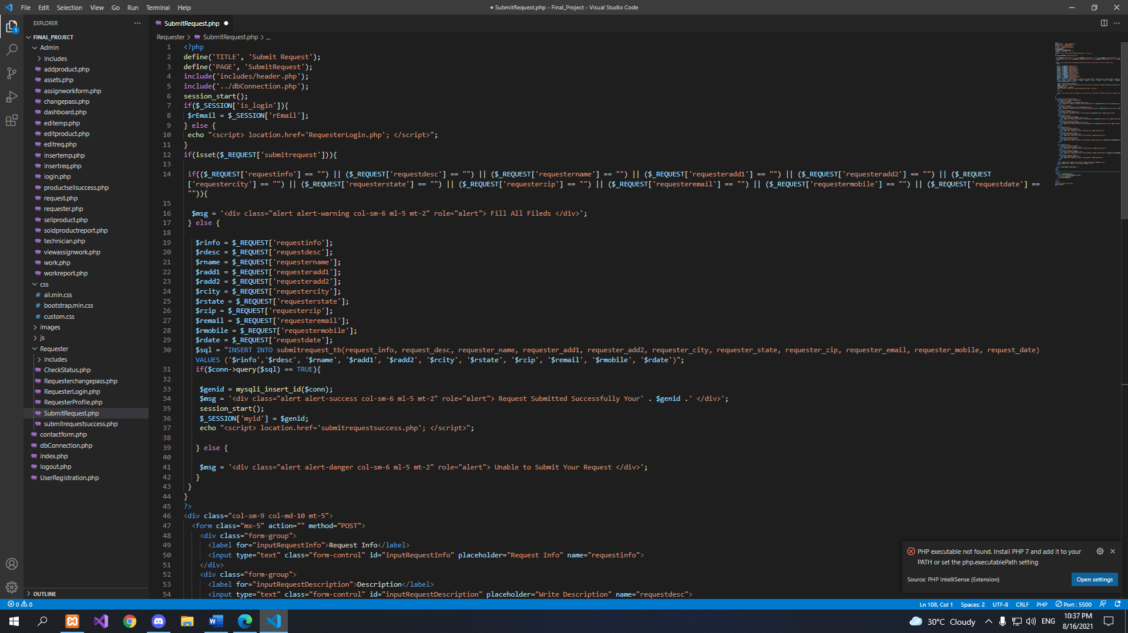

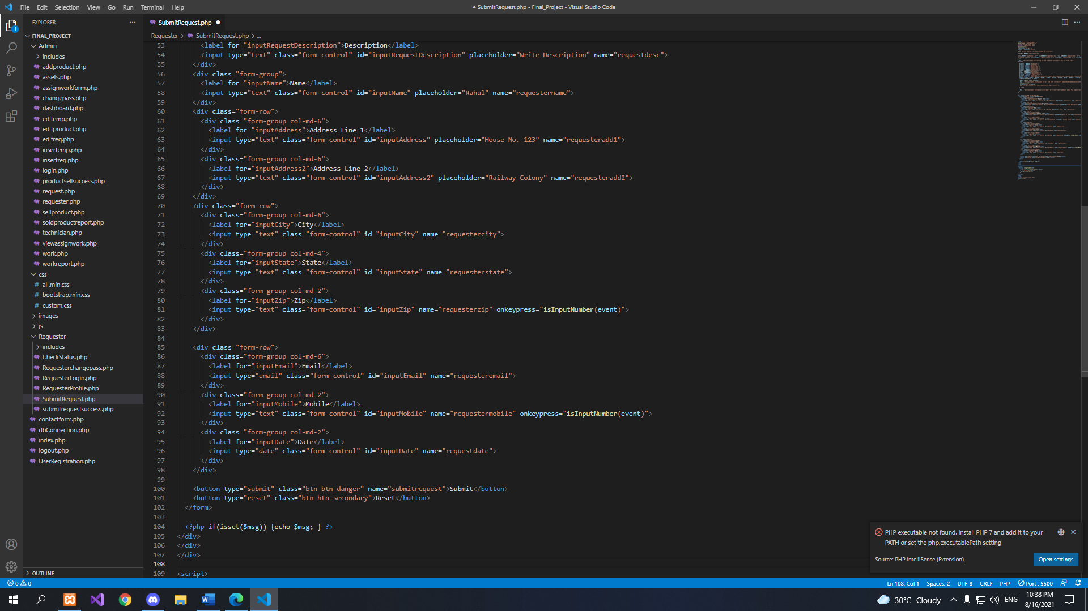

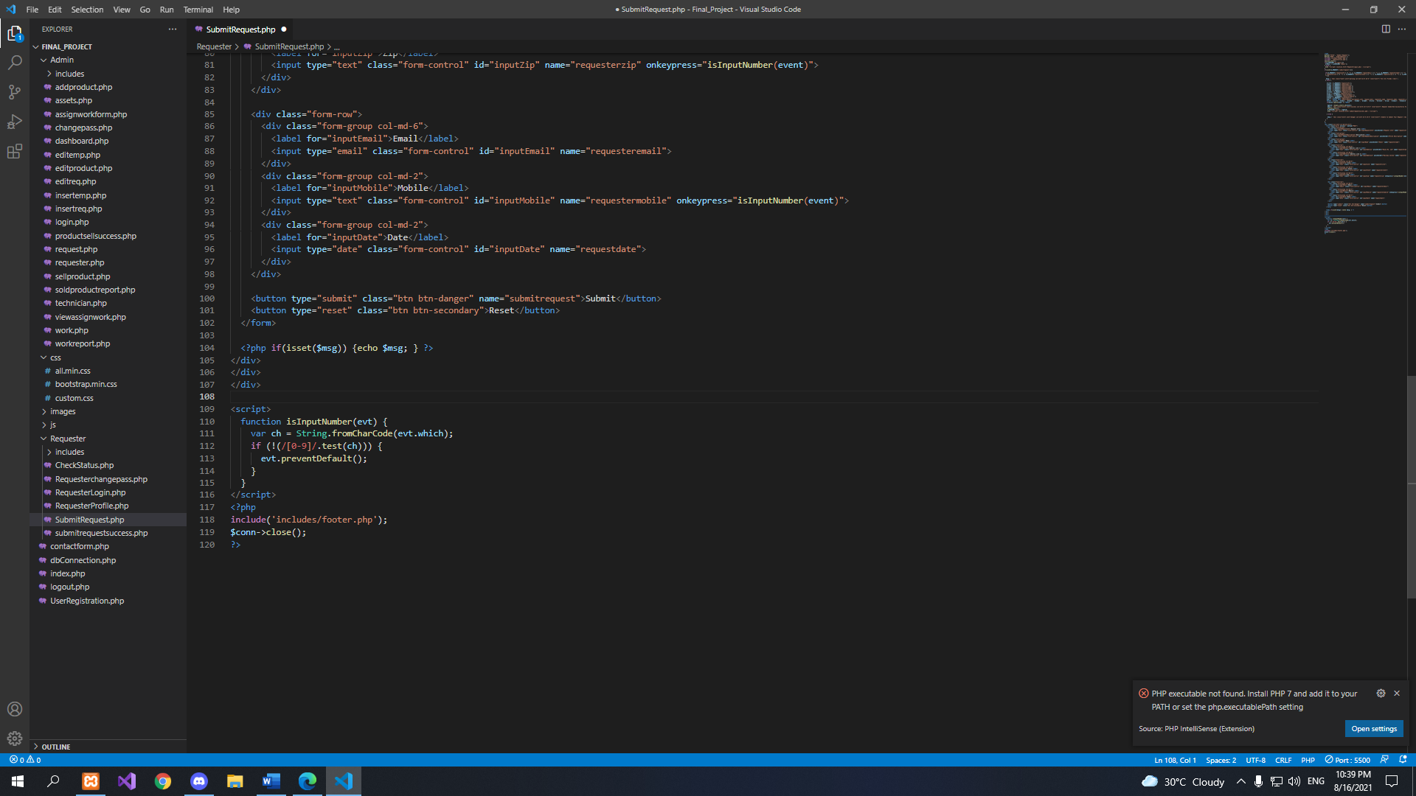

***checkout.php***

